**WEEK 1 ASSIGNMENT**

**Design Pattern**

**-Dipanshu Modi**

**Superset ID: 6373703**

**Exercise 1: Implementing the Singleton Pattern**

1. **Code:**

package Design_Pattern.Exercise_1;

class Logger

{

    private static Logger loggerObj;

    private Logger()

    {

        System.out.println("Logger Clas is initialized");

    }

    public static Logger getInstance()

    {

        if(loggerObj==null)

            loggerObj = new Logger();

        return loggerObj;

    }

    public void log(String message)

    {

        System.out.println("LOG: "+ message);

    }

}

public class Main

{

    public static void main(String[] args) {

        Logger obj1 = Logger.getInstance();

        Logger obj2 = Logger.getInstance();

        obj1.log("Message from first object");

        obj2.log("Message from second object");

        if(obj1==obj2)

            System.out.println("Singleton Confirmed");

        else

            System.out.println("Singleton Failed");

    }

}

1. **Output:**

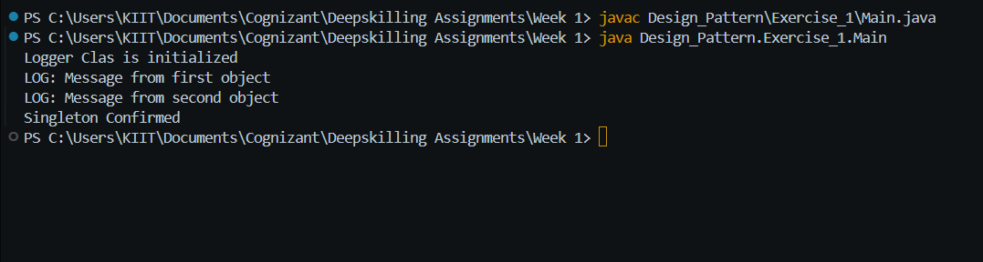

**Exercise 2: Implementing the Factory Method Pattern**

1. **Code:**

package Design_Pattern.Exercise_2;

interface Document {

    void open();

}

class WordDocument implements Document {

    public void open() {

        System.out.println("Opening Word Document...");

    }

}

class PdfDocument implements Document {

    public void open() {

        System.out.println("Opening PDF Document...");

    }

}

class ExcelDocument implements Document {

    public void open() {

        System.out.println("Opening Excel Document...");

    }

}

abstract class DocumentFactory {

    public abstract Document createDocument();

}

class WordDocumentFactory extends DocumentFactory {

    public Document createDocument() {

        return new WordDocument();

    }

}

class PdfDocumentFactory extends DocumentFactory {

    public Document createDocument() {

        return new PdfDocument();

    }

}

class ExcelDocumentFactory extends DocumentFactory {

    public Document createDocument() {

        return new ExcelDocument();

    }

}

public class Main {

    public static void main(String[] args) {

        DocumentFactory wordFactory = new WordDocumentFactory();

        Document wordDoc = wordFactory.createDocument();

        wordDoc.open();

        DocumentFactory pdfFactory = new PdfDocumentFactory();

        Document pdfDoc = pdfFactory.createDocument();

        pdfDoc.open();

        DocumentFactory excelFactory = new ExcelDocumentFactory();

        Document excelDoc = excelFactory.createDocument();

        excelDoc.open();

    }

}

1. **Output:**

